Republic Polytechnic



School of Engineering

E112: Engineering Design

Business Plan: [Eclectic]

Lecturer: [Ong Hock Seng]

Class: [W15A]

Team No: [4]

Team members:

ONG ZHEN YANG (17046589)

KITTY ANAGATA SARI (17035614)

RICA SAA'YAH PUTRI BINTE SAMSHUL SAHRI (17052413)

WANG YANG (17039763)

XIE LILI (17023754)

AY 2017 Semester 1

CONTENT PAGE

|  |  |
| --- | --- |
| **CONTENT** | **PAGE NUMBER** |
| **Acknowledgement** | **3** |
| **Introduction(Vision, Mission, Executive Summary)** | **4** |
| **Objectives** | **5** |
| **Target Market(Analysis)** | **5-9** |
| **Market Strategy** | **10** |
| **Marketing Mix 4P’s** | **11-16** |
| **Competitive Target Analysis** | **17-19** |
| **Financial Plan** | **20-21** |
| **Positioning** | **22** |
| **Conclusion** | **23** |
| **Contributor’s Page** | **24** |
| **Appendix with references** | **25-27** |

**Acknowledgement**

Many individuals played a significant role towards the realisation of this thesis, some gave moral support and provided the facilities for us to study, others gave financial support while some others transferred knowledge both implicit and tacit knowledge and they all deserve this special recognition.

First and foremost, we would like to thank our supervisor of this project, Mr Ong Hock Seng for the valuable guidance and advice. He inspired us greatly to work in this project. His willingness to motivate us contributed tremendously to our project. We also would like to thank him for showing us some example that related to the topic of our project.

In addition, we would like to thank the authority of Republic Polytechnic for providing us with a good environment and the facilities to complete this project. It gave us an opportunity to participate and learn about business planning. Finally, an honourable mention goes to our families and friends for their understandings and supports on us in completing this project. Without helps of the that mentioned above, we would have faced many difficulties while doing this.

**Introduction**

**“Eclectic”**

The name of our company will be called “Eclectic” and the word literally means deriving ideas, style, or taste from a broad and diverse range of sources. As it implies, we want to be limitlessly innovative and to rely on an indispensable number of sources and support to emerge as a respected, idiosyncratic company.

**Vision:**  
To be an impeccable company most admired for its people, partnership and performance.

**Mission:**  
Our Company's foundation is built on our Values, which distinguish us and guide our actions. "Eclectic" will always conduct business in a socially responsible and ethical manner. We respect the law, support universal human rights, protect the environment, and benefit the communities where we work.

**Executive Summary**

The writers of this document, “Eclectic”, is formed of a group of Republic Polytechnic students that have initiated their first venture and they aim to achieve exceptional business platforms that designs and manufactures consumer electronics, computer software, peripherals and computer accessories. The product research and developments recorded in this document includes data on our current prototype, a multipurpose Laptop Stand.

The purpose of this report is to inform why it would be vital to expand technology in useful gadgets that is continuing to advance with corporate businesses. Like any other amateur venture, we are known to be personal and committed to the cause, thus we want to build a strong relationship and build a strong business plan that can last for many years to come. "Eclectic" is about helping and focusing on the consumer needs and wants when it comes to technology that has an impact that can change the life of others around the world and this includes non-profit acts such as “Corporate Social Responsibility”.

Throughout the report, each component/section reflects direction on how they plan to overcome present disadvantages that might raise concerns and how “Eclectic” benefits when expanding businesses into relevant industries. Attached at the end of this document are appendices which provides graphics and references while identifying global diversity in what they want to achieve and how they were inspired. In conjunction, "Eclectic" has a cultural orientation profile that helps provides insight to how the organization functions and how potential customers will benefit upon implementation.

Our SMART Objectives

|  |
| --- |
| Specific - our objective is to create a laptop stand that brings comfort and convenience to laptop users.  Measurable - We have conducted a survey of 100 participants. We must compare with our product against the survey to ensure that the most popular choices are met based on the target users.  Attainable - With the time given, it is achievable provided that all the team members do their part and commit their time into this project.  Realistic - With our chosen materials (cardboard), our laptop stand can be made to be functioned with the given time left as it does not require a lot amount of work to cut it compared to wood etc.  Time Bound - Business plan deadline: End of Week 12  - Actual prototype & presentation: Week 13 |

Below is compilation of relevant research data which supports the rational of the objectives that “Eclectic” has set.

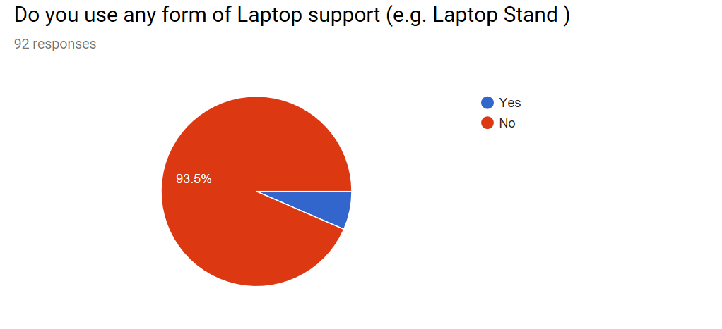

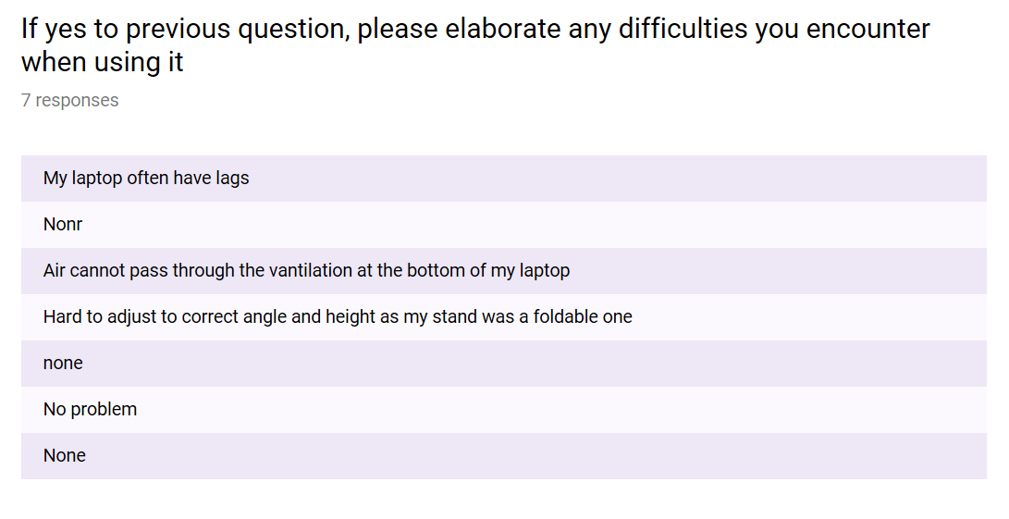

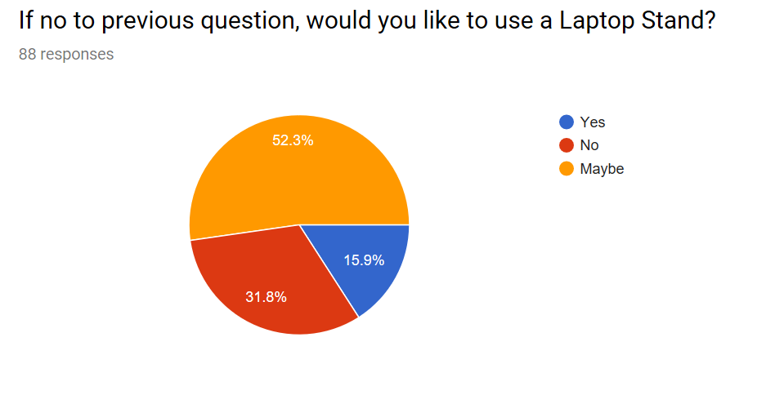

**Target Market**

Target Market Breakdown

Given the current state of Singapore’s bustling economy, having a well-defined target market has evolved to becoming more than just essential. No one can afford to target everyone like how North Korea wants to fire Nuclear Warheads/Weapons of Mass Destruction at every country. Small businesses such as “Eclectic” must effectively compete with large companies by targeting a niche market. Therefore, that is exactly what this section is devised for.

Target Market Analysis

Introduction – This Target Market Analysis report focuses on the strategy recommendations for the country of Singapore, with a focus on its downtown study areas and subareas relevant to “Eclectic’s” prototype(laptop stand). This narrative report includes descriptions and details on the optimal market strategy for the next 5 years, including a combination of new construction and adaptive reuse of analysis.

“Eclectic’s” target market consist student and working adults where use of their personal laptops is a daily routine.

This is based from the relevant survey data shown below:

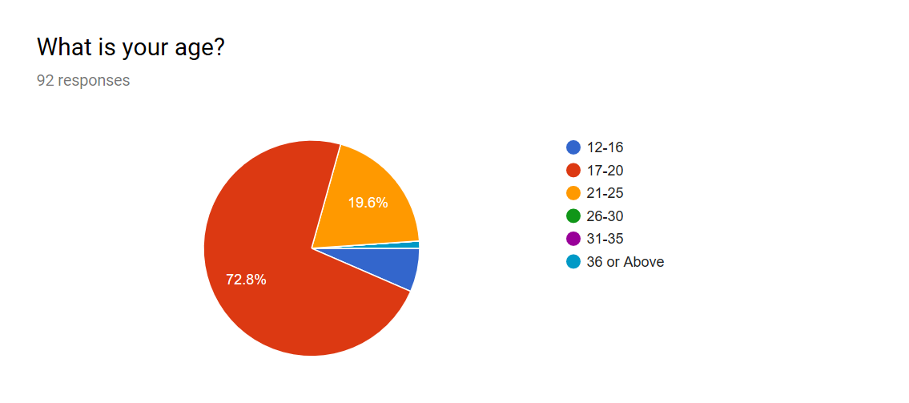

Target Market Analysis

This page contains elaborative data of our Target Market.

Profile for Each Group:

Ø **Students**

Age Range: 16-25 years old

Gender: Both

Targeted Aspects:

* Laptop stands are highly portable and allow you to use your computer in an inclined view almost anywhere.
* If you are a student, a laptop stand will be much easier to transport from home to school and back again.
* Laptop stands take up less room on a desk or table and can be put away when not in use. This is because the purpose of the laptop stand is to allow better space management.

Ø **Young Adults**

Age Range: 21-25 years old(Or Older)

Gender: High Percentage is expected to be male

Targeted Aspects:

* Our Laptop Stand has more features as compared other similar products.
* Our Laptop Stand is generally less expensive overall and offer a better overall value.
* Our Laptop Stand provides a more comfortable and a much easier use. It should be noted that an aftermarket large, comfortable mouse and mouse pad are also possible with a laptop stand.
* Laptop Stands have a lower risk of theft, which means less chance of losing it.

Target Market Analysis

ABSTRACTED AND EDITED FROM: <http://www.businessdictionary.com/definition/demographic-factors.html>

In the next two pages, socioeconomic characteristics of our Target Market expressed statistically, such as age, sex, education level, income level, marital status, occupation, religion, birth rate, death rate, average size of a family, average age at marriage. A census is a collection of the demographic factors associated with every member of a population.

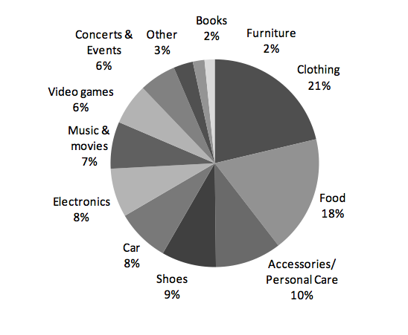

Image from: <https://www.pinterest.com/pin/536843218056973670/>

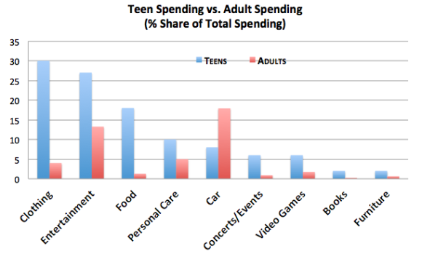

<https://pricetags.wordpress.com/2013/04/12/how-teenagers-and-adults-spend-their-money/>

Demographic factors - Based on the figures above, students(mainly teenagers aged 16-19) mostly spends on clothing, entertainment and food while adults mostly spend on transportation, personal care and also entertainment. In view of this, “Eclectic” will also target adults with an substantial income to maintain affordable pricing.

Target Market Analysis

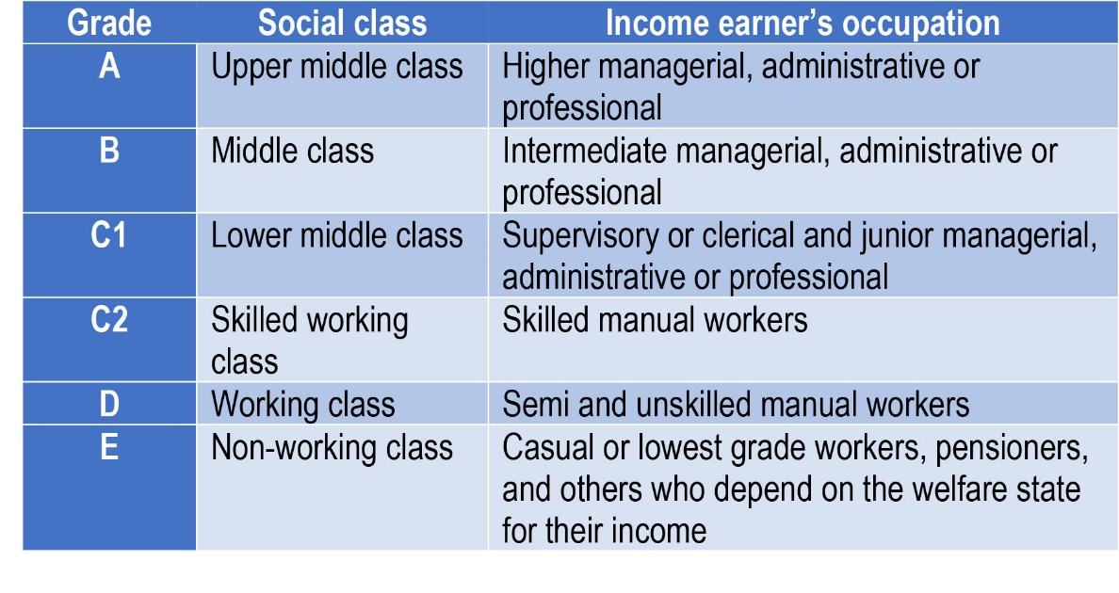

Image from: <http://userscontent2.emaze.com/images/48ea6ce9-f218-42c2-927c-b31d924dcf46/635463368936190889_tablesocialgradeUK.jpg>

As shown on the picture above, the breakdown of different classes of adults’ income is categorised into Upper middle class, Middle class, Lower middle class, Skilled working class, working class, non-working class. The Upper upper class is not included because this category includes aristocrats who own casinos, resorts and even armies. This suggests that they might even own the franchise which “Eclectic” may work with to sell the product. The picture below shows the final breakdown of capital we are connecting with in this venture.

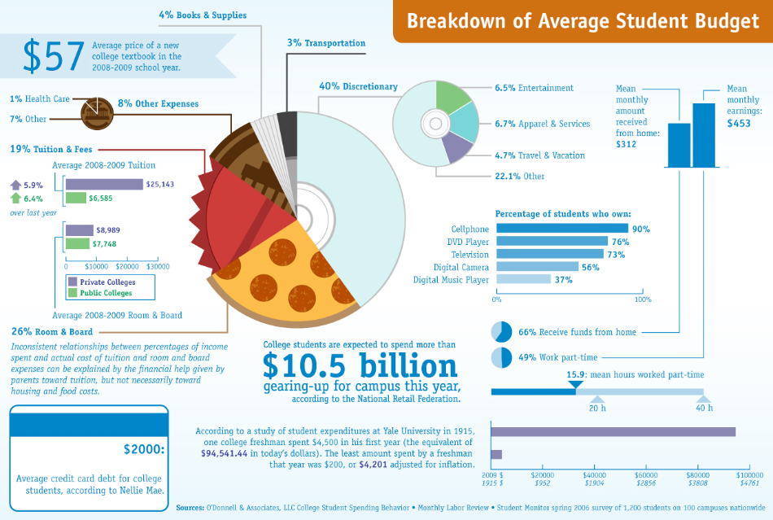

Image from: <http://www.getbettergradesnow.com/blog/wp-content/uploads/2011/09/GetBetterGradesNow-Dot-Com-Student-Budget-Infographic.jpg>

**Market Strategy**

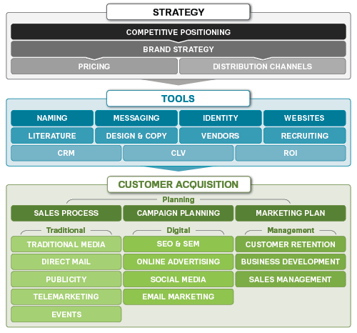

Image from: <http://www.marketingmo.com/strategic-planning/marketing-plans-budgets/>

“Eclectic” has chosen to use the above market strategies above in form of a sales process. It contains a revised marketing process map, which groups marketing activities from 30 different subjects into three buckets, to clarify how the activities fit together in the revenue-generation process:

Strategy: High-level conceptualization of go-to-market strategy

Tools: The collateral, assets, software and processes to use during tactical execution

Customer Acquisition: The marketing mediums and tactics used to achieve strategic and revenue goals

Advantages:

|  |  |
| --- | --- |
| Improve sales revenue and performance   * increase market penetration * new products * enter new markets * forward integration | Improve profitability   * lower costs * change price * vertical integration to control cost |
| Harvesting   * marketing support reduced or limited * investment reduced or limited turnaround strategies * a large effort and support for putting the |  |

Michael Porter has a different set of generic strategies which will be explained in the competitive target analysis.

**Marketing Mix – 4P’s**

Product

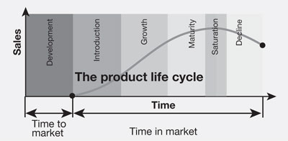

Image from: <http://businesscasestudies.co.uk/jd-sports/balancing-the-product-portfolio-to-satisfy-customer-demand/the-product-life-cycle.html>

1. Product Development- The idea is developed from market research, customer demand, updating existing products or in response to a competitor’s product.
2. Introduction - Conducted market surveys and has established estimates for market size and composition.
3. Growth - Competition is low. Sales volume grows rapidly.
4. Maturity - Demand levels off and sales volume increases at a slower rate.
5. Decline - Sales volume decreases and many products are eventually discontinued.

As highlighted, we are currently in the product development stage.

Product

“Eclectic” successfully created our product (a multi-purpose laptop stand) using concrete application requires one to carefully capture the relevant domain knowledge in an ontology between the consumer’s needs and Eclectic’s ambition. This is a subtle, error prone, and time-consuming task, which can be further hindered if the domain experts(ourselves) are not even experts in engineering and, conversely, engineers are often not sufficiently familiar with the domain to be modelled. From the beginnings, we conducted research which was driven by the aim to provide various forms of support for the users’ laptops, assisting them in the high-quality ontologies. We have included the ubiquitous task of ontology classification (our features) as followed.

Laptop Stand Features:

The main aim of our product is to allow ease of better space management and to allow consumers an overall light laptop stand which allows them to work and study more efficiently in many applications.

Summary of Product features(advantages) and uses:

|  |  |
| --- | --- |
| 1. Light-weight | A light material is used to make our product. This is important because many potential customers do not like a heavy laptop, much less a heavy accessory such as a laptop stand. |
| 1. Adjustable | This means that they can adjust the stand(incline the 1st board onto 2nd board) to achieve a comfortable angle to view their laptop screen. |
| 1. Convertible | The laptop stand can be converted from a height that allows an “angled view” to a “flat base view.” |
| 1. Cable-Holder | This helps to organize and manage cords and wires with two cable holder solutions. |
| 1. LED Lamp | LED lighting contrivances light and energy more efficiently in many applications. |
| 1. Phone Holder | A cell phone mount or holder is a type of device that secures a cell phone in a fixed location. These mounts are normally installed in places where one needs to have his or her hands free to do something else. Based on our research, this can help with better space management on the desk. |
| 1. Cup Holder | The cup holder is free standing to hold cups securely on a circular flat surface |

Product(Final Assembly Coloured)

|  |  |
| --- | --- |
| “Expected Outcome” | “Right & Left side view” |

**Attached to this document is also the CAD drawing for your reference.**

Product

The following is a compilation of survey data used as relevant research to support our prototype research and development.

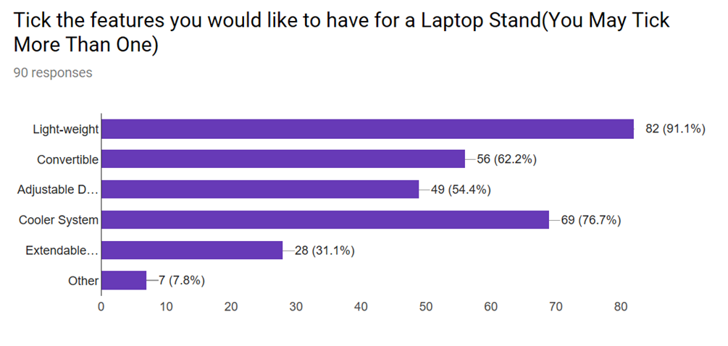

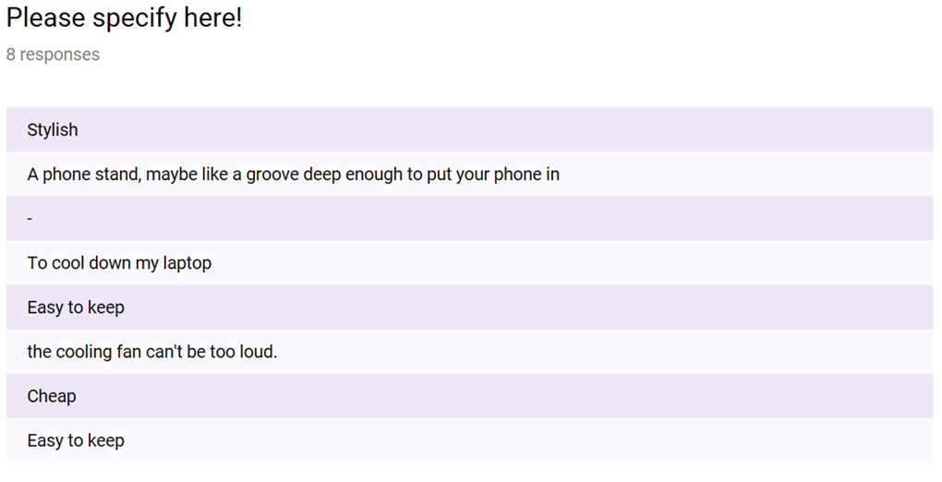

Place

**Placement Strategy**

Product distribution (or placement) is the process of making a product or service accessible for use or consumption by a consumer or business user, using direct or indirect means with intermediaries. Based on our research, we have discovered 3 main distribution types.

**Distribution Types**

1. Selective distribution means that the producer relies on a few intermediaries to carry their product. This strategy is commonly observed for more specialized goods that are carried through specialist dealers, for example, brands of craft tools, or large appliances.

“Eclectic” has decided to initially market the product using selective distribution. The decision regarding how to distribute a product has, as its foundation, basic economic concepts, such as utility. Utility represents the advantage or fulfilment a customer receives from consuming a good or service. Understanding the utility, a consumer expects to receive from a product being offered can lead marketers to the correct distribution strategy. Hence, the following content will explain how we choose to fulfil the utility based in Singapore.

Price

Pricing Schemes:

1. Penetration pricing

Penetration pricing is the practice of offering a low price for a new product or service during its initial offering to lure customers away from competitors.

|  |  |
| --- | --- |
| Image result for penetration pricing | As highlighted, we chose penetration pricing and this is because it can be a successful marketing strategy when applied correctly. It can often increase both market share and sales volume. With reference to the graph, the high sales volume can also lead to lower production costs and higher inventory turnover, both of which are positive for any firm with fixed overhead. There is a possibility that customers may switch out of curiosity but then leave the brand once prices begin to rise to levels more in line with rivals. However, there are many ways to keep our target audience engaged to prevent this.  Penetration pricing also matches with our competitive advantage(Michael Porter’s strategies) which will be explained later on. |

Image from: <http://faculty.msb.edu/homak/homahelpsite/webhelp/Content/Price_Penetration.htm>

Price

**Relevant Survey Data Collected**

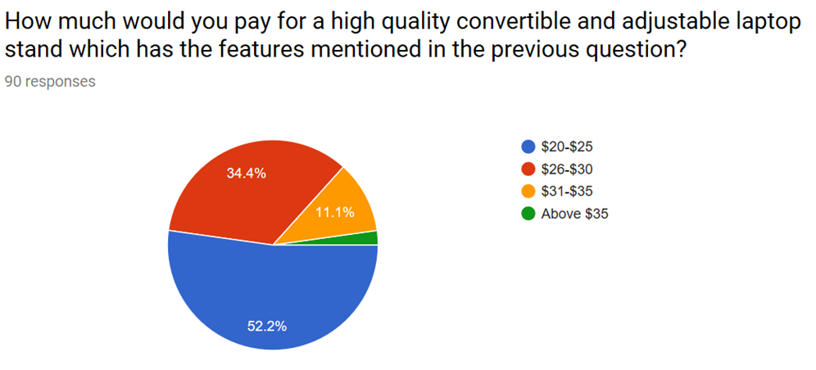

**Top competitor’s product price, $79.90**

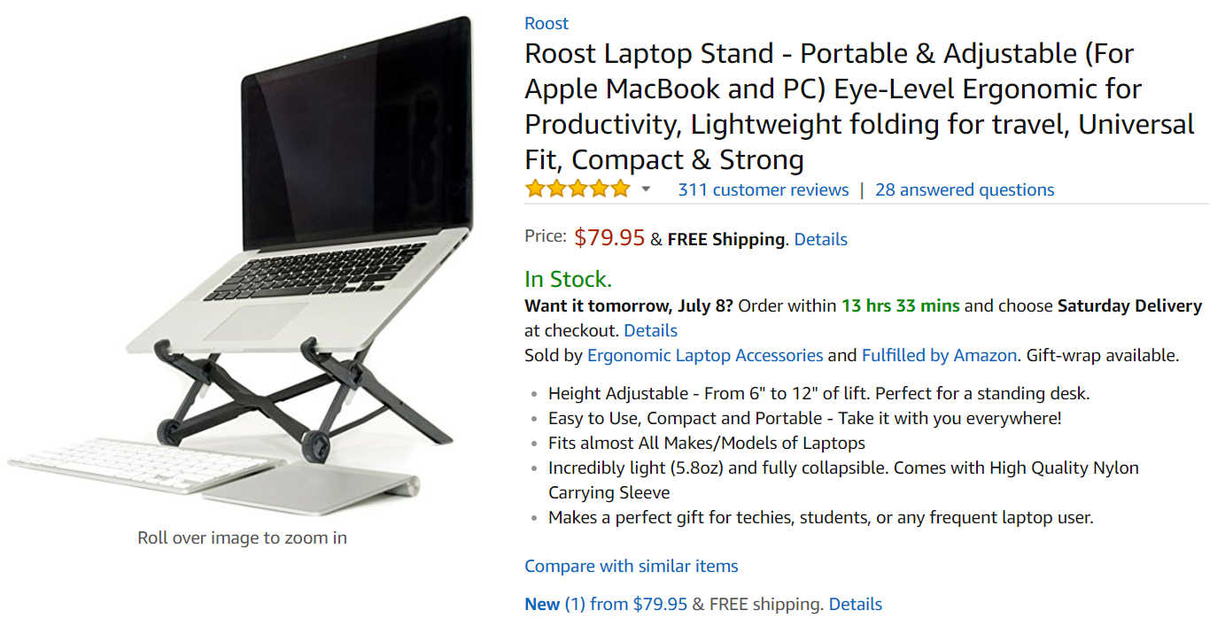

Reference: <https://www.amazon.com/exec/obidos/ASIN/B01C9KG8IG/ezvid02-20>

After considering our penetration price scheme, reference pricing strategy, the survey data recorded above and our top competitor’s top product price, we have decided to price the laptop stand at an affordable $20-$25.

Promotion

**Social Media Advertising**

As the Web has evolved into a medium that fosters social connection, social media has experienced an astounding growth in the last few years. Social media consists of both social networking sites and social bookmarking sites and includes blogs, video sharing sites such as YouTube, microblogging platform Twitter, Facebook, LinkedIn, Stumbleupon and the like. This is another method that is very advantageous for “Eclectic” and this is because our target audience is directly associated with the current influx of revenue for the Social Media industry.



Image from: <http://minddigitalglobe.com/social-media-marketing/>

Advantages of Social Media Advertising

* Social media sites are great for building customer relationship and offers an incredible reach and the opportunity to connect with customers in an entirely new way
* Offers a wide reach, with its potential for viral marketing
* Traffic generated can be extremely targeted
* Social media tools are relatively inexpensive

Disadvantages of Social Media Advertising

* Targeting is low because of the diversity and breadth of audiences, resulting in low return in investment as visitors do not convert
* Visitors mainly go to social media sites to socialize, and are not interested in product advertisements
* Traffic is typically in the learning stage of the buying process; hence it is more important to inform and teach than sell outright

**BUSINESS PLANNING SWOT**

|  |  |
| --- | --- |
|  |  |
| **INTERNAL FACTORS** | |
| **STRENGTHS (+)** | **WEAKNESSES (-)** |
| * Many potential customers * Customer satisfaction - customers do say they like the research and development ongoing and may spread positive word of mouth to others. We can appeal with this. * Experienced business leader * The company can consider affordable pricing * Eye-catching logo which gives some exposure when performing on-site services | * Singaporeans don't pay much attention to marketing – dependent on word-of-mouth and number of website hits * Website development skills are purely informational and static * Don't have professional telemarketers * Don't have much of a marketing budget * Lack of engineering skills when making the product * Lack of investors * Lack of corporate experience within the team |
|  |  |
| **EXTERNAL FACTORS** | |
| **OPPORTUNITIES (+)** | **THREATS (-)** |
| * Take advantage of the increasing popularity of features other companies’ products do not possess * Increasing use of social media * Positive Trends in the Field * Continued Market Development | * Expense of running media advertisements * There are similar products in the market * There is a constant influx of new laptop support products that are being developed and tested |
|  |  |

**Competitive Target Analysis**

Competitive Target Analysis(Michael Porter’s Strategies)

“Porter called the generic strategies "Cost Leadership" (no frills), "Differentiation" (creating uniquely desirable products and services) and "Focus" (offering a specialized service in a niche market). He then subdivided the Focus strategy into two parts: "Cost Focus" and "Differentiation Focus." These are shown in figure below.” “Quoted from “Mindtool’s”

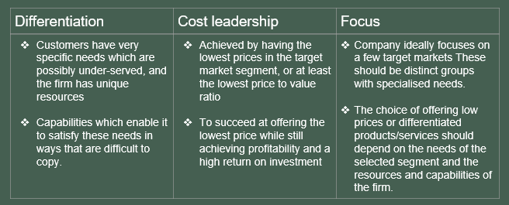

By using Michael Porter’s Strategies, we will finalise our pricing strategy as an effort to improve our competitive advantage. There are three main strategies. We will be using the Cost Leadership implementation method.

Main reasons for choosing cost leadership:

* Low-cost competitive strategy
* Aimed at broad mass market
* Cost reduction

Competitive Target Analysis(Michael Porter’s Strategies)

Below is a compilation of research that support our choice for choosing Cost Leadership.

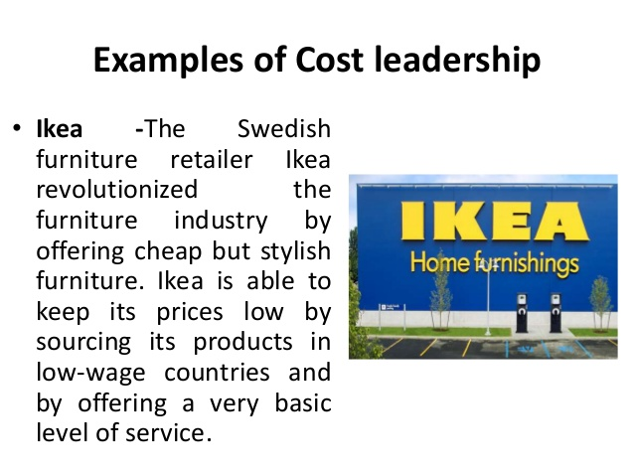

Images from: <https://www.slideshare.net/manumelwin/focused-cost-leadership-strategy-strategic-management-manu-melwin-joy>

Competitive Target Analysis(Conclusion)

In conclusion, “Eclectic” has produced this section which focuses on the key aspects of competitor analysis. It defines competitor analysis and the research data provides suggestions on how to write a good competitor analysis. The section identifies sources on where to find information for a good competitor analysis, and gives good illustrations(SWOT & PEST) of utilising information for competitor analysis.

In utilising competitor analysis as part of strategy formulation, “Eclectic” can adapt and build their own pricing strategies and be able to compete effectively, improve performance and gain market share in their businesses. With reference to the figure, in many instances, “Eclectic” can tap new markets or build new niches.

**Financial Plan**

Even though most of the team may not have a financial background, we’ll need to understand the numbers on the various schedules and statements that make up the Financial Projections section and be prepared to answer questions about the assumptions used to create them. You, as well as those who read our business plan, can quickly gain a clear picture of the financial aspects of “Eclectic’s” venture through this format.

Projected Sources & Uses of Cash

The Projected Sources & Uses of Cash shows the total amount of funding required to finance the start-up and opening of the restaurant, where the funds are expected to come from and how these funds will be spent.

The numbers on this worksheet are generated from information entered on other supporting worksheets. You may refer to the appendix for the references.

**ECLECTIC**

**Projected Sources & Uses of Cash**

**Development & Start-up Period**

**SOURCES OF CASH:**

|  |  |  |  |  |  |  |
| --- | --- | --- | --- | --- | --- | --- |
| Equity Contributions | **$** | **400,000** |  |  |  |  |
| Loan Financing |  | **677,675** |  |  |  |  |
| **TOTAL SOURCES OF CASH** |  | **$** | | | **1,077,675** |  |
|  |  |  |  |  |  |  |
| **USES OF CASH:** |  | **0** |  |  |  |  |
| Land & Building |  |  |  |  |  |
| Stocks Account(Maintenance) |  | **400,000** |  |  |  |  |
| Leasehold Improvements |  | **175,000** |  |  |  |  |
| Manufacturing |  | **75,000** |  |  |  |  |
| Professional Services |  | **19,500** |  |  |  |  |
| Organizational & Development |  | **34,475** |  |  |  |  |
| Research & Development |  | **66,500** |  |  |  |  |
| Exterior Finishes & Equipment |  | **48,500** |  |  |  |  |
| Pre-Opening Expenses |  | **108,700** |  |  |  |  |
| Working Capital & Contingency |  | **150,000** |  |  |  |  |
| **TOTAL USES OF CASH** |  | **$** | | | **1,077,675** |  |
|  |  |  |  |  |  |  |

|  |  |  |  |  |  |  |  |  |
| --- | --- | --- | --- | --- | --- | --- | --- | --- |
|  |  |  |  | Eclectic |  |  |  |  |
|  |  |  |  | **Capital Budget(Start-up Year)** |  |  |  |  |
|  |  |  |  |  | **TOTAL COST Detail** | |  |  |
|  |  |  |  |  |  |  |  |  |
|  |  | **LAND & BUILDING** | | | **0** |  |  |  |
|  |  |  | Land | |  |  |  |  |
|  |  |  | Building - Construction / Contractor Fees | |  |  |  |  |
|  |  | **LEASEHOLD IMPROVEMENTS** | | | **200,000** |  |  |  |
|  |  |  | Construction Contract | |  | 300,000 |  |  |
|  |  |  | Landlord Contribution | |  | (100,000) |  |  |
|  |  |  |  |  |  |  |  |  |
|  |  | **STOCKS ACCOUNT(TRADING ACCOUNT)** | | | **125,000** |  |  |  |
|  |  |  |  |  |  |  |  |  |
|  |  | **MABUFACTURING** | | | **32,500** |  |  |  |
|  |  |  |  |  |  |  |  |  |
|  |  | **PROFESSIONAL SERVICES** | | | **19,500** |  |  |  |
|  |  |  | Architect & Engineering | |  | 7,500 |  |  |
|  |  |  | Legal (lease & incorporation) | |  | 5,000 |  |  |
|  |  |  | Project Consultant | |  | 2,500 |  |  |
|  |  |  | Accounting & Tax | |  | 2,000 |  |  |
|  |  |  | Name, Logo & Graphic Design | |  | 2,500 |  |  |
|  |  |  |  |  |  |  |  |  |
|  |  | **ORGANIZATIONAL & DEVELOPMENT** | | | **34,475** |  |  |  |
|  |  |  | Deposits (utilities, sales tax, etc.) | |  | 3,000 |  |  |
|  |  |  | Insurance Binder (property, casualty, liability) | |  | 4,225 |  |  |
|  |  |  | Workers Comp. Binder | |  | 1,500 |  |  |
|  |  |  | Liquor License | |  | 5,500 |  |  |
|  |  |  | Building Permits | |  | 2,500 |  |  |
|  |  |  | Other Licenses & Permits | |  | 1,500 |  |  |
|  |  |  | Utility Deposits (gas, electric, water) | |  | 3,000 |  |  |
|  |  |  | Change, Operating Banks & Petty Cash | |  | 1,000 |  |  |
|  |  |  | Menus / Menu Boards | |  | 3,750 |  |  |
|  |  |  | Lease Deposit | |  | 5,000 |  |  |
|  |  |  | Travel, Research, Concept Development | |  | 3,500 |  |  |
|  |  |  |  |  |  |  |  |  |
|  |  | **INTERIOR FINISHES & EQUIPMENT** | | | **66,500** |  |  |  |
|  |  |  | Kitchen Smallwares | |  | 12,000 |  |  |
|  |  |  | Artwork & Specialty Décor | |  | 10,000 |  |  |
|  |  |  | Security System | |  | 3,000 |  |  |
|  |  |  | Music/Sound/Audio-Visual Systems | |  | 12,500 |  |  |
|  |  |  | Cash Register / Point of Sale | |  | 20,000 |  |  |
|  |  |  | Phone System | |  | 4,500 |  |  |
|  |  |  | Office Equipment / Computer | |  | 2,500 |  |  |
|  |  |  | Office Supplies | |  | 500 |  |  |
|  |  |  | Interior Signs | |  | 1,500 |  |  |
|  |  |  |  |  |  |  |  |  |
|  |  | **EXTERIOR FINISHES & EQUIPMENT** | | | **48,500** |  |  |  |
|  |  |  | Landscaping | |  | 12,000 |  |  |
|  |  |  | Exterior Signs & Decorations | |  | 15,000 |  |  |
|  |  |  | Resurfacing | |  | 15,000 |  |  |
|  |  |  | Parking Bumpers | |  | 4,000 |  |  |
|  |  |  | Parking Lot Striping | |  | 2,500 |  |  |
|  |  |  |  |  |  |  |  |  |
|  |  | **PRE-OPENING EXPENSES** | | | **108,700** |  |  |  |
|  |  |  | Construction Period Utilities | |  | 4,000 |  |  |
|  |  |  | Construction Period Building Lease | |  | 7,500 |  |  |
|  |  |  | Construction Period Interest | |  | 2,500 |  |  |
|  |  |  | Uniforms | |  | 1,200 |  |  |
|  |  |  | **Opening Inventories -** | |  |  |  |  |
|  |  |  |  | Food |  | 10,000 |  |  |
|  |  |  |  | Beer, Liquor & Wine |  | 15,000 |  |  |
|  |  |  |  | Paper & Other Supplies |  | 5,000 |  |  |
|  |  |  |  | **Marketing -** |  |  |  |  |
|  |  |  |  | Advertising |  | 7,500 |  |  |
|  |  |  |  | Public Relations |  | 10,000 |  |  |
|  |  |  |  | Opening Parties |  | 7,000 |  |  |
|  |  |  |  | **Personnel -** |  |  |  |  |
|  |  |  |  | Management & Chef |  | 15,000 |  |  |
|  |  |  |  | Hourly Employees |  | 15,000 |  |  |
|  |  |  |  | Payroll Taxes & Employee Beneifts |  | 3,000 |  |  |
|  |  |  |  | Payroll Taxes |  | 6,000 |  |  |
|  |  |  |  |  |  |  |  |  |
|  |  | **WORKING CAPITAL & CONTINGENCY** | | | **130,525** |  |  |  |
|  |  |  |  | Working Capital |  | 75,000 |  |  |
|  |  |  |  | Contingency |  | 55,525 |  |  |
|  |  | **TOTAL PROJECT COST** | | | **$ 765,700** |  |  |  |
|  |  | | | |  |  |  |  |
|  |  | | | |  |  |  |  |

**Positioning**

|  |  |
| --- | --- |
|  | |
|  | **We have rated ourselves with the following ratings with relevance to the information to the link below. In addition, further supporting information includes the fact that we have no corporate experience.**  **With reference to this link:** <https://wiki.ezvid.com/best-laptop-stands> |

**Conclusion**

Throughout this document, it has been suggested to observe other business and special research developments of all types, and talk to our facilitator for new ideas and solutions to problems. This was done by collaborating multiple sources to compile a list of resource materials that would have be quite useful to planners.

In addition, considerations include referring to industry leaders to get a different perspective on organizational skills and business management.

Some late details must be handled with care. One matter that must be taken care of promptly is to extend thanks to individuals, firms, and organizations that helped with this document. A personal note mentioning specific contributions is strongly recommended on our end.

We as planners can also prepare an event notebook including a complete report from every committee. By featuring all kinds of information-budgets, telephone numbers, outlines, news releases, contracts, and even a list of mistakes to avoid. It's also a great way to preserve event histories and traditions.

**In conclusion, we have learned about the importance of business management through many mediums and we could not have done it without the help of Mr Ong Hock Seng**



**Contributor’s Page**

|  |  |  |  |  |  |
| --- | --- | --- | --- | --- | --- |
|  | **Zhen Yang** | **Kitty** | **Rica** | **Wang Yang** | **Lili** |
| **Acknowledgement** |  |  |  |  |  |
| **Introduction(Vision, Mission, Executive Summary)** |  |  |  |  |  |
| **Objectives** |  |  |  |  |  |
| **Target Market(Analysis)** |  |  |  |  |  |
| **Market Strategy** |  |  |  |  |  |
| **Marketing Mix 4P’s** |  |  |  |  |  |
| **Competitive Target Analysis** |  |  |  |  |  |
| **Financial Plan** |  |  |  |  |  |
| **Positioning** |  |  |  |  |  |
| **Conclusion** |  |  |  |  |  |
| **Appendix** |  |  |  |  |  |

**Highlighted indicates the relevant contributors.**

**Appendix:**

References

|  |
| --- |
| **Target Market**  Target Market Breakdown  <http://www.conceptdraw.com/samples/marketing-sale-diagrams-target-circular-diagrams> |
| **Market Strategy**  Introduction and Format  <http://www.ryerson.ca/~kjensen/marketing/chapter9.pdf> |
| **Marketing Mix – The 4p’s**  Promotion Research  <https://www.powerhomebiz.com/marketing-tips/advertising/advantages-and-disadvantages-advertising-mediums.htm>  Promotional Market Statistics  <http://www.digi-labs.net/blog/promotional-market-industry-statistics/>  Research of doing Business in Singapore(Place)  <http://sethlui.com/pros-cons-business-singapore/>  Placement Strategy  <https://www.boundless.com/marketing/textbooks/boundless-marketing-textbook/introduction-to-marketing-1/introduction-to-marketing-18/product-placement-promotion-and-price-108-4454/>  Supply Chain in Singapore(Place)  <https://www.edb.gov.sg/content/edb/en/industries/industries/logistics-and-supply-chain-management.html>  Penetration Pricing  <http://www.investopedia.com/terms/p/penetration-pricing.asp>  Advertising Mediums(Promotion)  <https://www.powerhomebiz.com/marketing-tips/advertising/advantages-and-disadvantages-advertising-mediums.htm> |
| **Competitive Target Analysis**  SWOT Template  <https://www.smartsheet.com/14-free-swot-analysis-templates> |
| **Financial Planning**  Finance Guide and Templates  <https://www.sampletemplates.com/business-templates/financial-plan-template-example.html>  <https://mymission.lamission.edu/userdata/eguaralj/docs/How%20to%20prepare%20a%20business%20plan_4.16.2013.pdf>  <http://www.plannersearch.org/financial-planning/20financialplanningquestionsthatyouneedananswerto>  Formulas  Image result for financial planning formulas  <http://www.dummies.com/personal-finance/investing/financial-formulas/>  Related image  <http://www.investopedia.com/articles/04/012104.asp>  Image result for financial plan formulas  <https://www.pinterest.com/rbcla1/accounting-ratios-and-financial-analysis/?lp=true> |

Others:

|  |
| --- |
| Software & Applications Used  Image result for inventor professional 2018  Inventor Professional 2018 – CAD Drawings |